**Modular JavaScript (Working with Modules)**

**Splitting Code in a Sub-optimal Way**

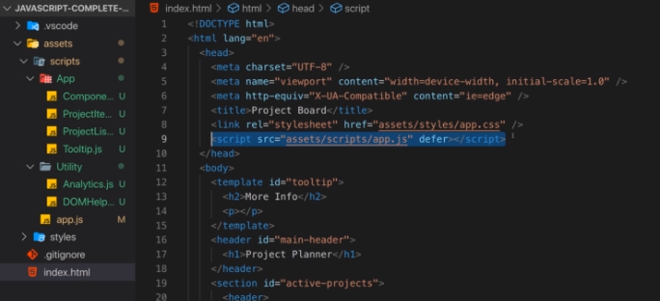

**A First Step Towards JavaScript Modules**